Tasks on Cloudfront and Route – 53

- Configure VPC peering in cross regions.
For that we need create 2-vpc in different regions
1-vpc in N.Virginia
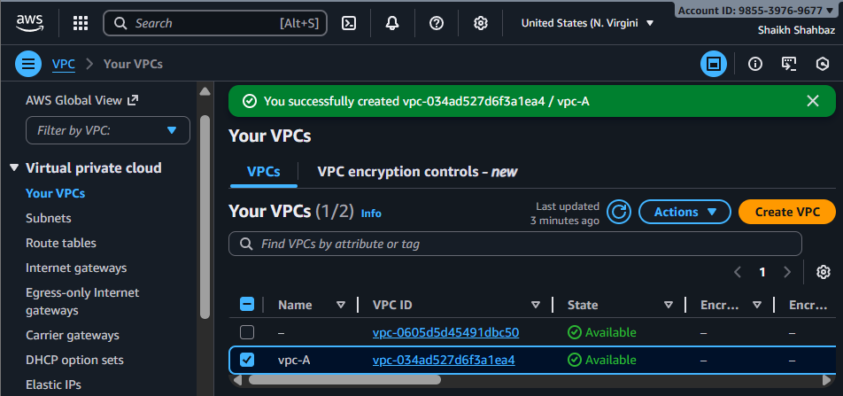
2-vpc in N.California
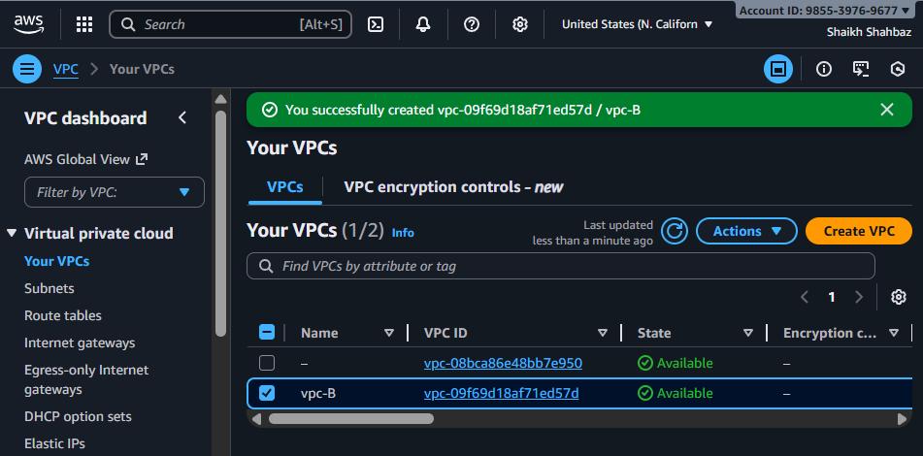

Step 1: Create VPC Peering Request (Region A <N.Virginia> → Region B <N.California>)
Go to VPC → Peering Connections
Click Create Peering Connection
Name: vpcA-to-vpcB
Requester VPC: select VPC in Region A <N.Virginia>
Accepter VPC: enter VPC ID from Region B <N.California>
Create.
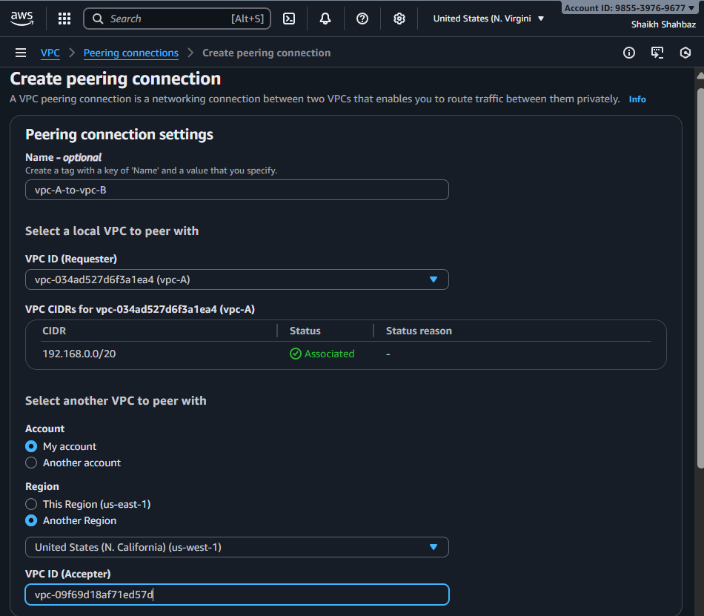

Step 2: Accept Peering (Region B <N.California>)
Switch to Region B <N.California>
Open Peering Connections → Actions → Accept Request
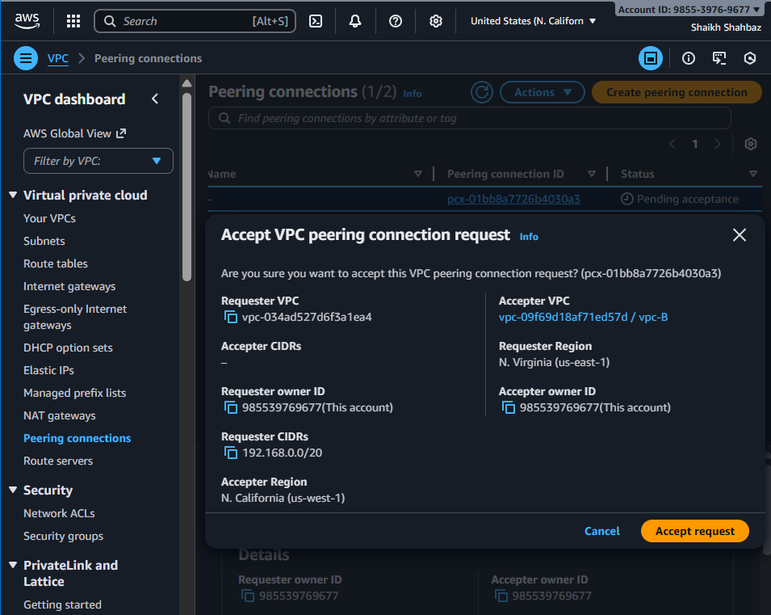

Step 3: Update Route Tables
Now we must update both VPC route tables.
VPC | Add Route | Target
VPC-A | Destination: CIDR of VPC-B | Peering Connection
VPC-B | Destination: CIDR of VPC-A | Peering Connection
Vpc-A Route table
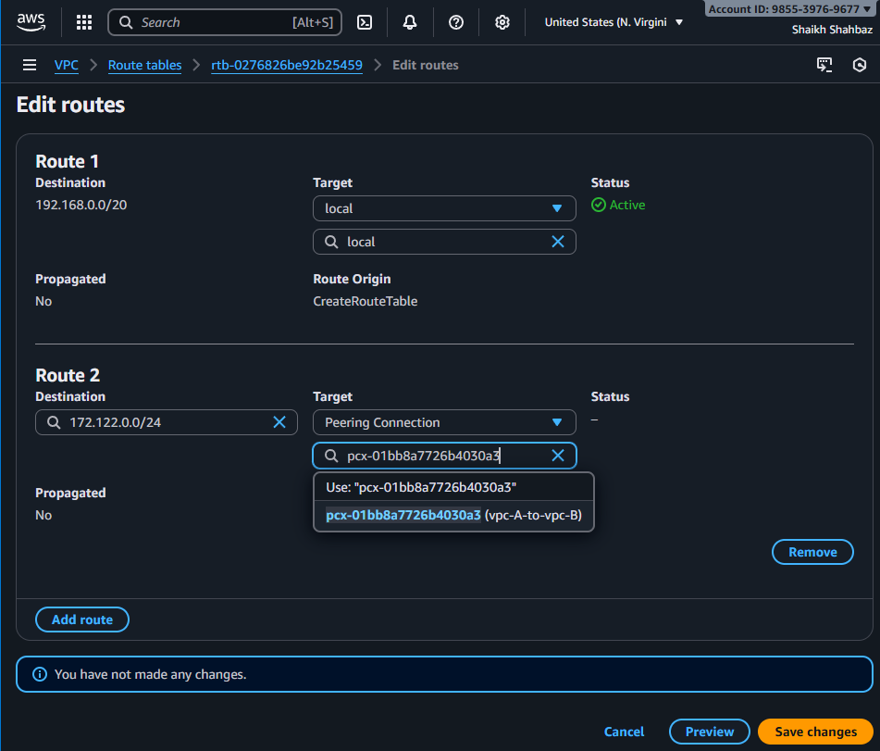
vpc-B Route table
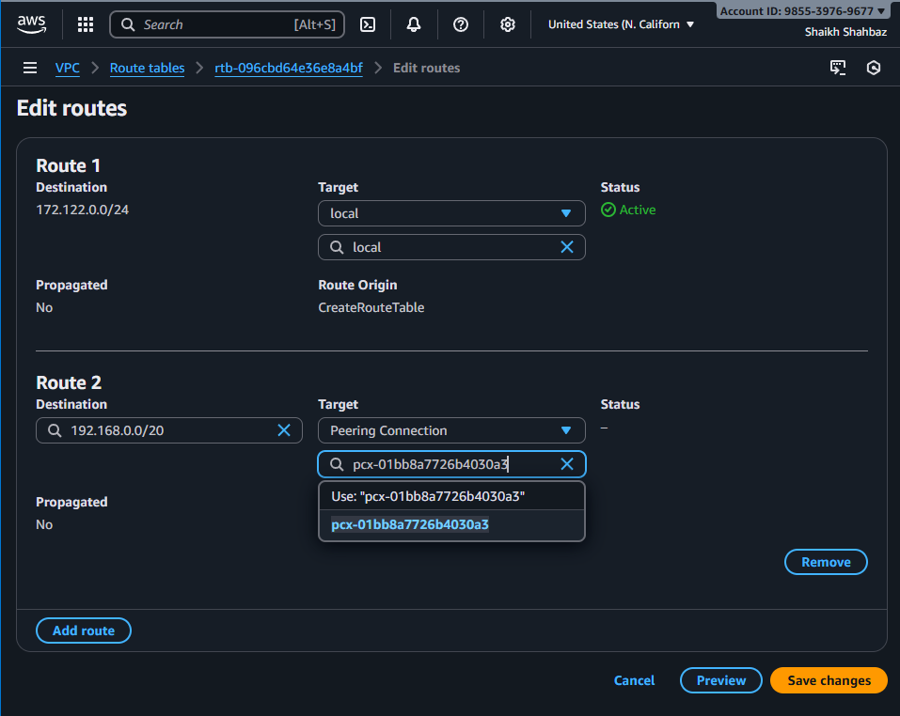
Step 4: Update Security Groups
Allow traffic from the other VPC CIDR
This part we have to do while we launch an instance
Because Security Group (S.G) Works at instance level

- Purchase one domain from GoDaddy.
Go to GoDaddy.com
Search domain Add to cart Purchase
After purchase,
Go to : GoDaddy My Products DNS
Then we have to keep this open to update name servers (later)
My Domain Name is <shaikhshahbazz.online>
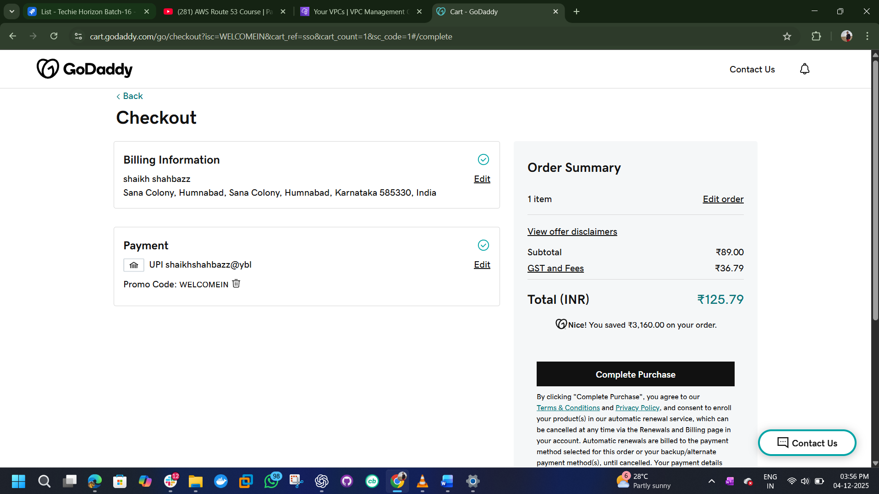
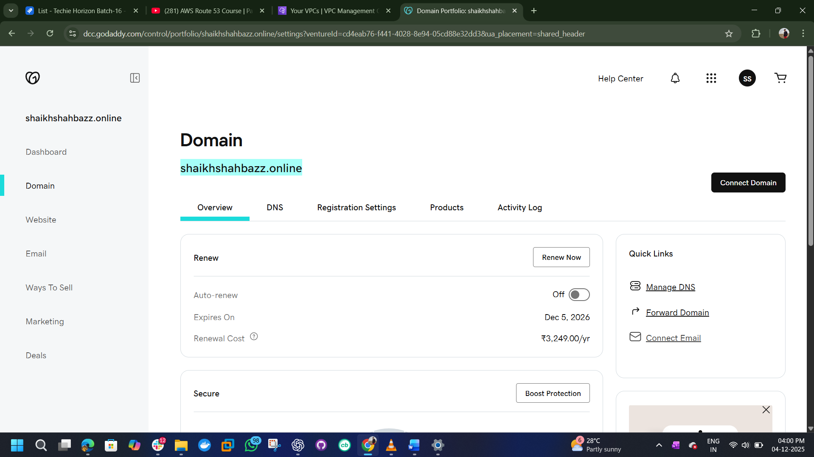

- Deploy static website in S3.
Step 1 : Create an s3 bucket
Bucket name = your domain name <shaikhshahbazz.online>
Disable “block all public access”
Enable static website hosting
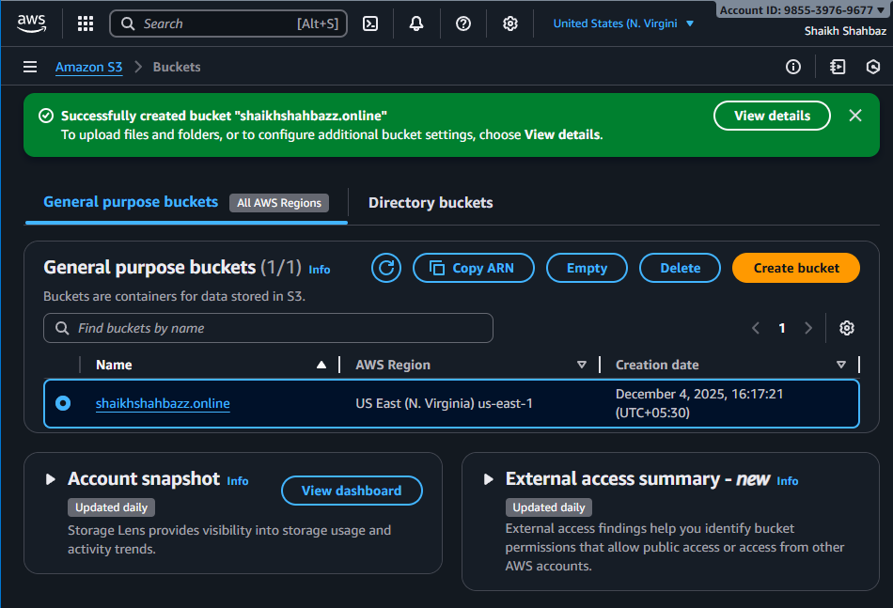

Step 2 : Upload website files
Index.html
Error.html
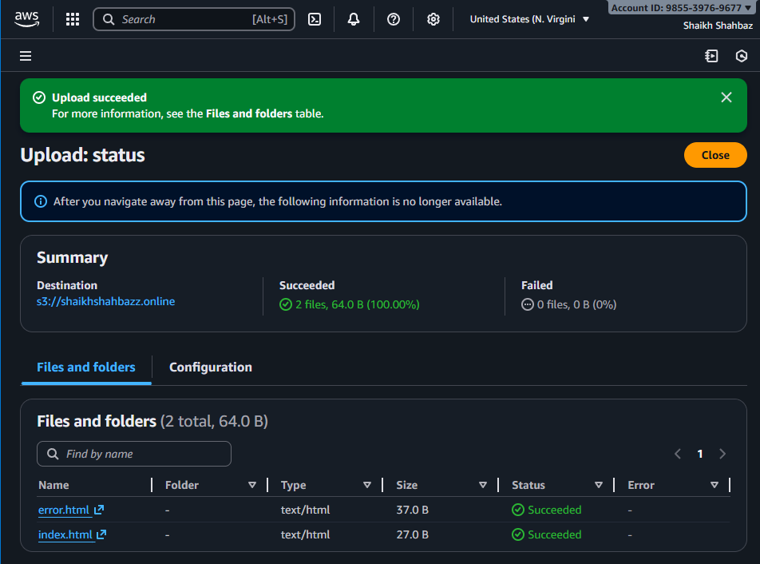

Step 3 : Add bucket policy
Go to permissions tab and add policy
Use policy
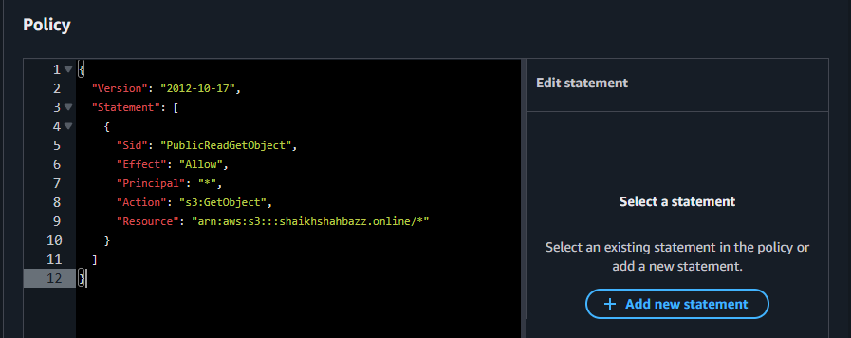
Now test the website
>copy the bucket website endpoint from static website hosting and check in browser.
>It should show the content of <index,html> file
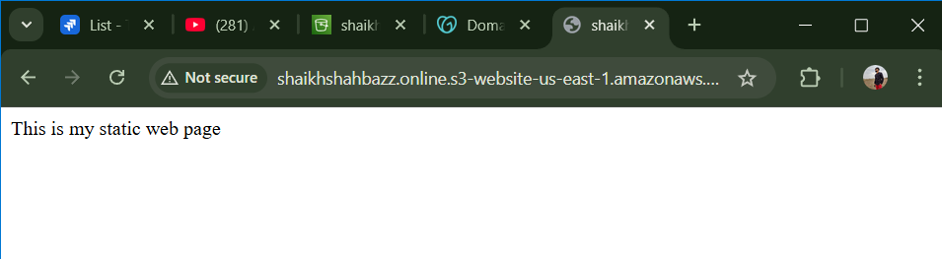

- Create a CDN and attach one SSL certificate.

Step 1: Request SSL Certificate in ACM
AWS Console → Services → Certificate Manager (ACM) → Region: us-east-1 → Request a certificate → Request a public certificate → Request
Go to ACM → Request certificate
Choose Public Certificate
Enter the following domains
shaikhshahbazz.online
www.shaikhshahbazz.online
Validation method → DNS validation
ACM will give you 2 CNAME records. (You will add these in Route 53 later.)
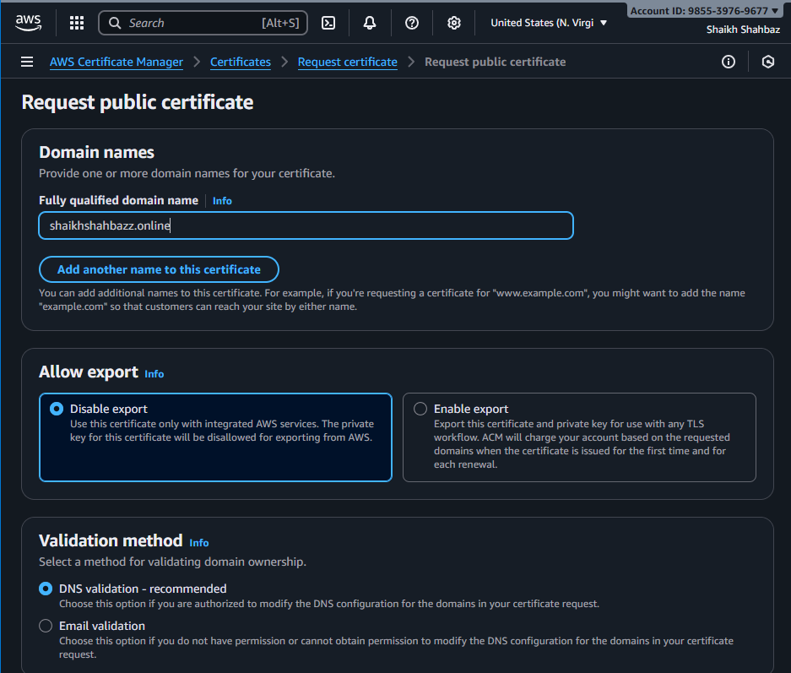
Create (or open) Route 53 Hosted Zone for shaikhshahbazz.online
Console path: AWS Console → Route 53 → Hosted zones → Click your hosted zone shaikhshahbazz.online (create it if not already created).
If you created the hosted zone now, copy the 4 NS names from Route 53 and update the nameservers at GoDaddy (GoDaddy → My Products → DNS → Change Nameservers → paste Route 53 NS). Wait for nameserver propagation (minutes to a few hours)

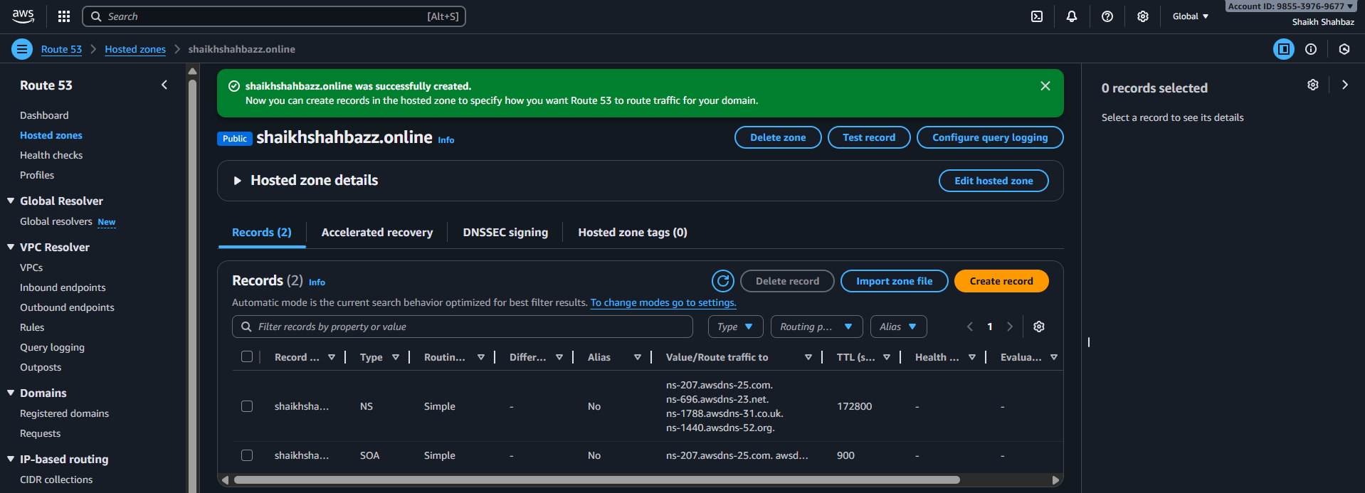

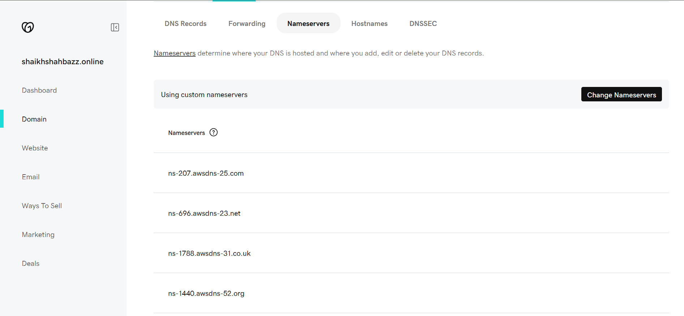

Step 2: Create CloudFront Distribution
Go to CloudFront → Create Distribution
Origin Domain
Select : shaikhshahbazz.online.s3-website-<region>.amazonaws.com
(we need to choose only the s3 website endpoint, not the rest API endpoint.)

CloudFront Configuration
Origin Settings
Origin name: shaikhshahbazz.online-origin
Protocol: HTTP only (S3 website hosting uses HTTP)
Default Cache Behavior
Viewer protocol policy:
Redirect HTTP → HTTPS
Distribution Settings
Alternate Domain Names (CNAMEs)
shaikhshahbazz.online
www.shaikhshahbazz.online
Custom SSL Certificate:
Select the validated ACM certificate for:
shaikhshahbazz.online
Leave other settings default
Create distribution.
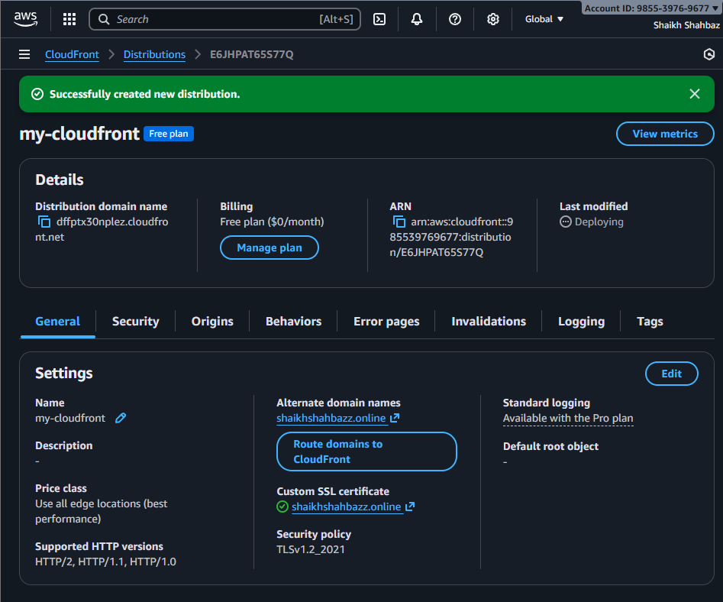

Step 3: (Important) DNS Validation from ACM
ACM gives you DNS records like:
Name: _abc123.shaikhshahbazz.online
Type: CNAME
Value: xyz.acm-validations.aws
Add them to Route 53 → Hosted Zone → “Create record”.
After 1–5 minutes, ACM will show "Validated".
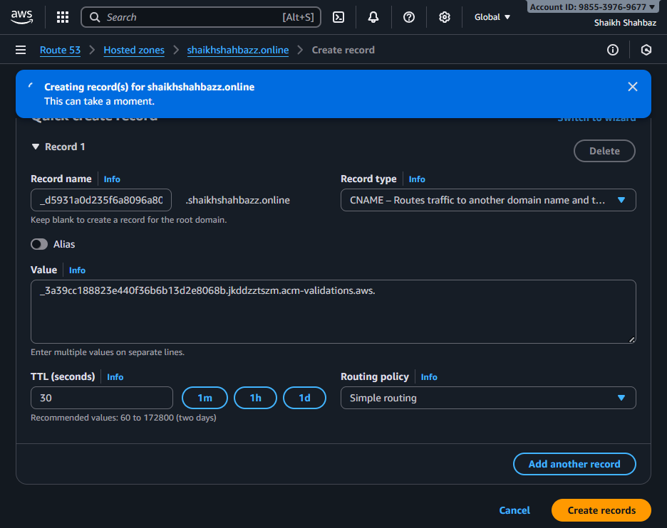
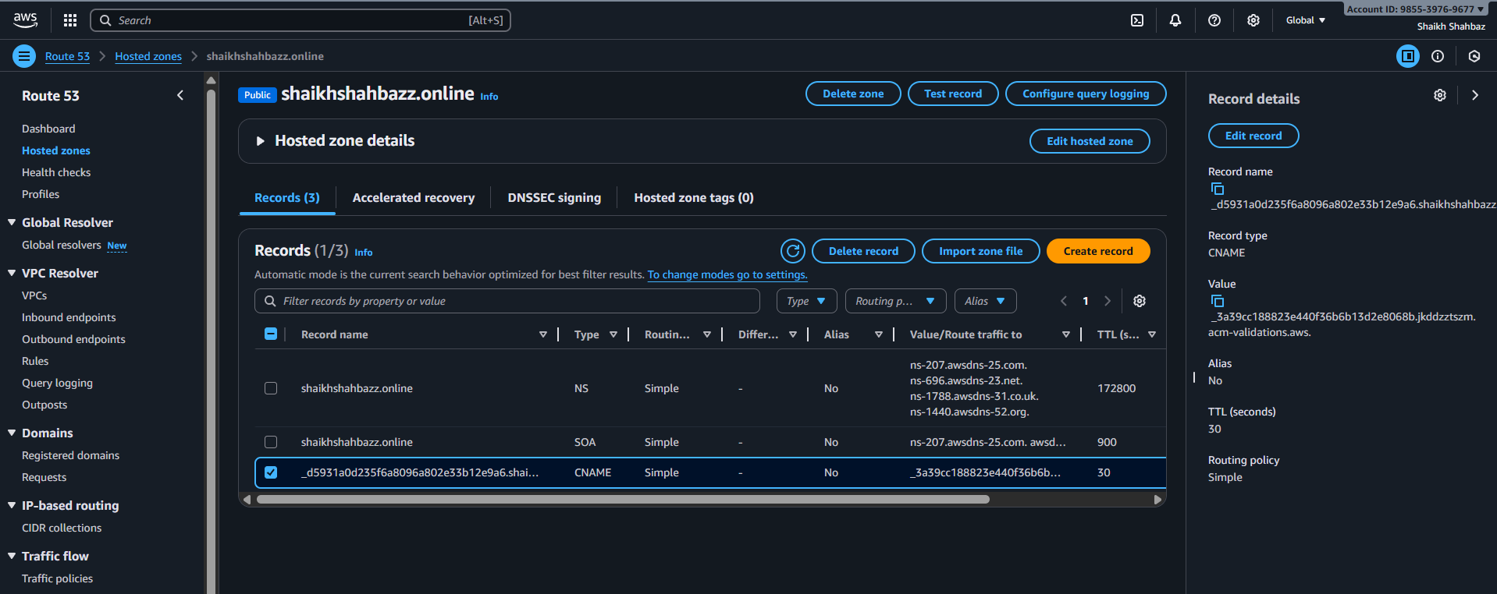

- Create a Route 53 hosted zone and map the domain with the CDN.
Console path: Route 53 → Hosted zones → shaikhshahbazz.online → Create record
Record A (root domain)
Record type: A (IPv4)
Record name: leave blank (root)
Alias: Yes
Alias target: Select your CloudFront distribution domain name (e.g., d1234abcd.cloudfront.net) from the Alias dropdown. Save.
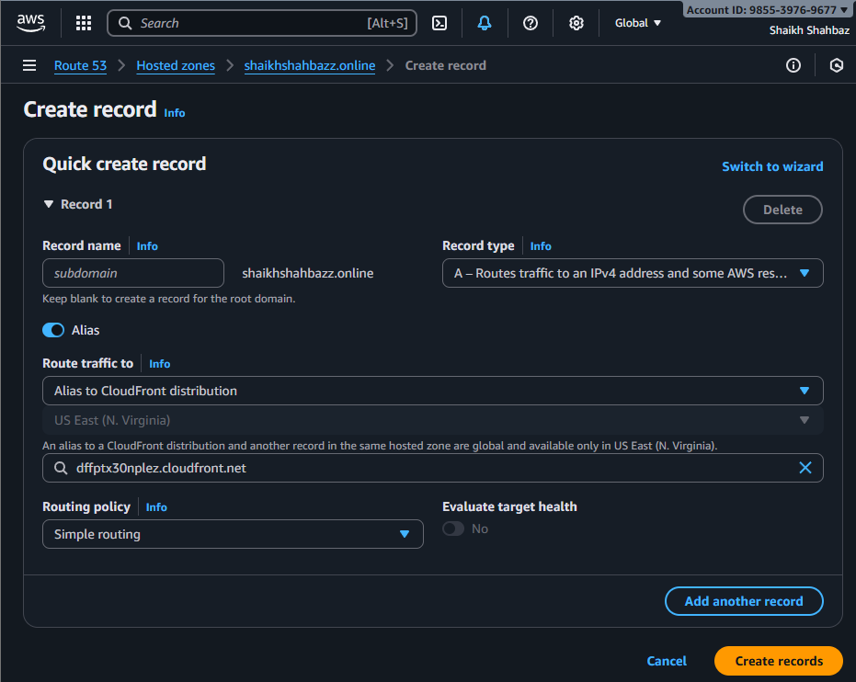
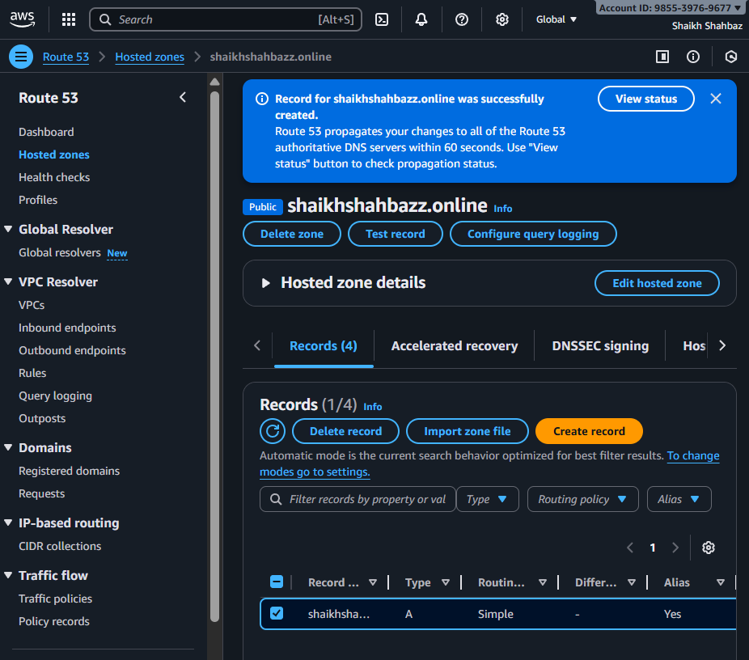
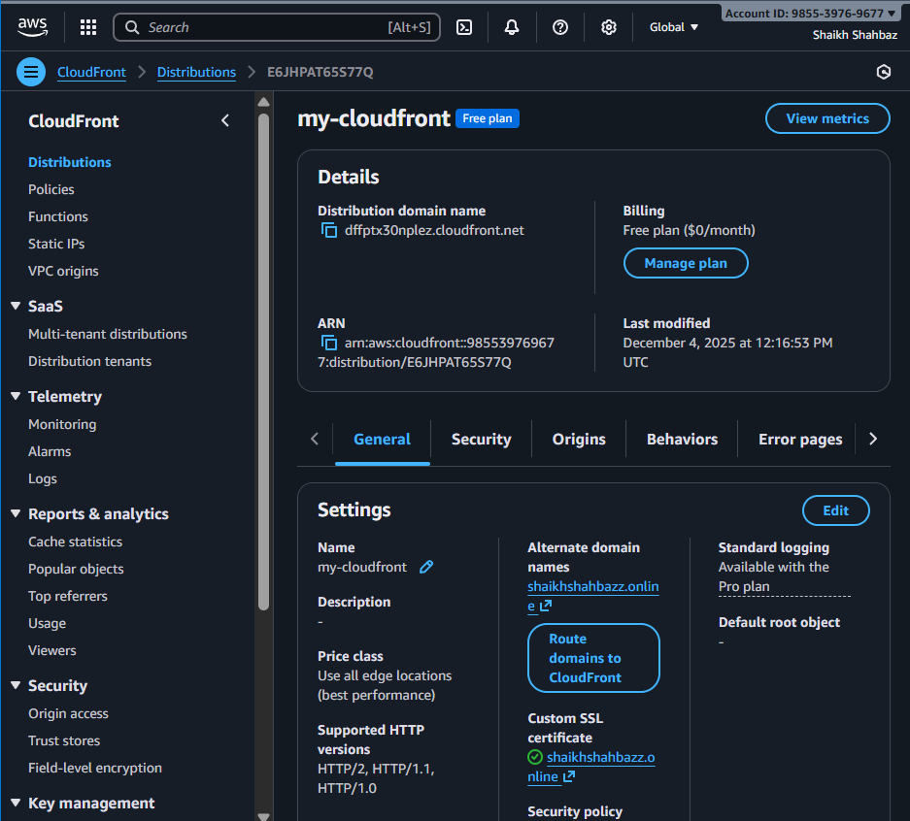

Now
Wait for CloudFront distribution status Deployed and Route 53 changes to propagate (Route 53 is instant; DNS caches may take a few minutes).
Visit:
- https://shaikhshahbazz.online
- https://www.shaikhshahbazz.online
You should see the site served over HTTPS and the browser padlock showing the ACM certificate is valid.
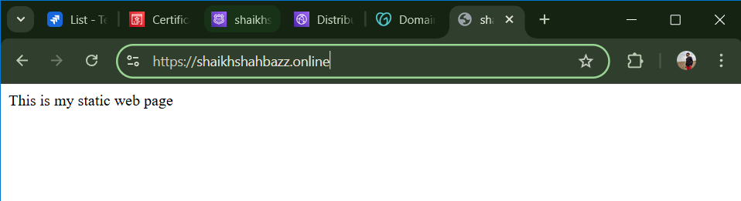

- Update the index.html in the S3 bucket and ensure the updated file is accessible using the domain name.
1. Update the index.html in your S3 bucket
Step 1: Go to your bucket
AWS Console → S3 → Bucket: shaikhshahbazz.online
Step 2: Delete or overwrite the old index.html
Click on index.html → Delete
(or simply upload a new file with the same name which will overwrite automatically)
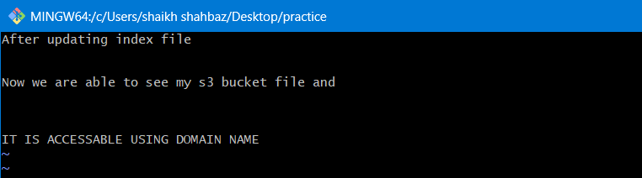
Step 3: Upload the new index.html
Click Upload
Add file → Choose your updated index.html
Click Upload
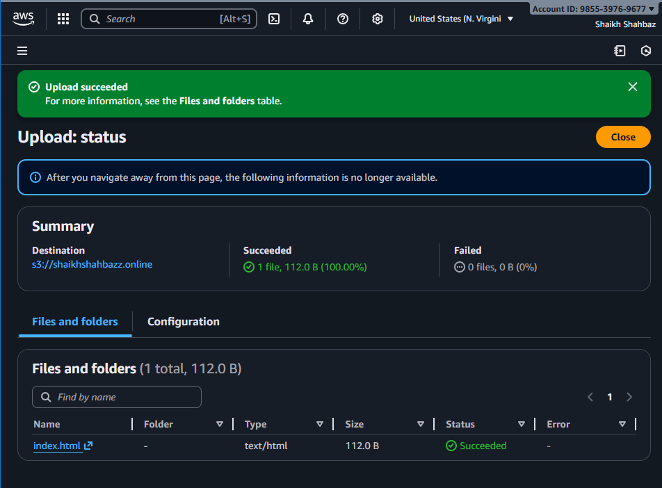

Step 4: Make sure the file is publicly accessible
(Only required if your CloudFront origin is the S3 website endpoint)
Go to the uploaded index.html → Permissions → ensure:
Object ACL is Public (if ACLs enabled)
OR bucket policy already allows public read (recommended)
Bucket policy must contain:
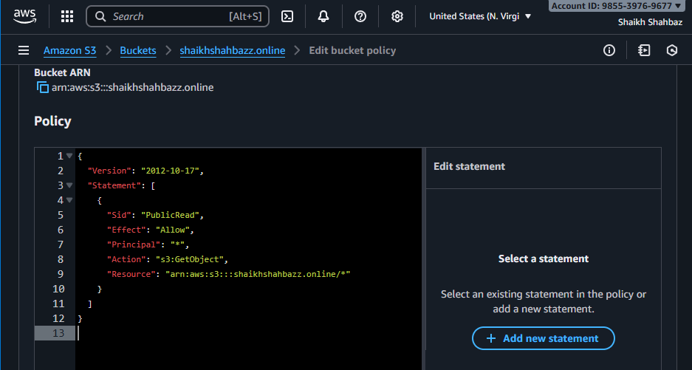

2. Invalidate CloudFront Cache (VERY IMPORTANT)
CloudFront caches your old index.html, so even if you upload a new file, visitors will still see the old version until cache expires.
Step 1: Go to CloudFront
Services → CloudFront → Distributions
Step 2: Select your distribution
Click on the distribution that is linked with your domain
(example: dxxxx.cloudfront.net)
Step 3: Create invalidation
- Go to Invalidations
- Click Create Invalidation
- In Paths, type: /index.html
- If you want to refresh everything: /*
- Click Invalidate
Wait 1-5 minutes
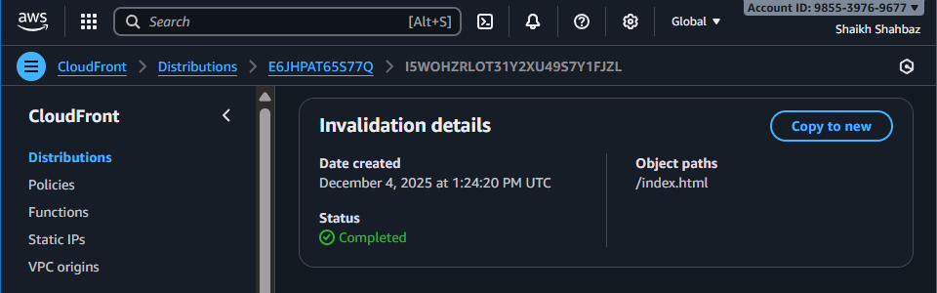

3. Test using your domain name
After invalidation completes:
Visit:
🔗 https://shaikhshahbazz.online
🔗 https://www.shaikhshahbazz.online
You should now see your updated website content.
This is before uploading index.html file in s3-bucket
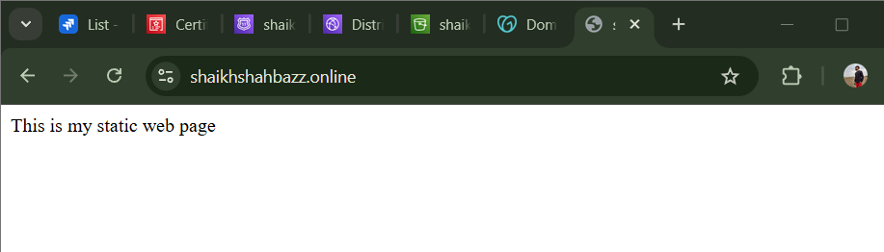
This is after uploading index.html file in s3-bucket and updating cloudfront Distribution service invalidation save
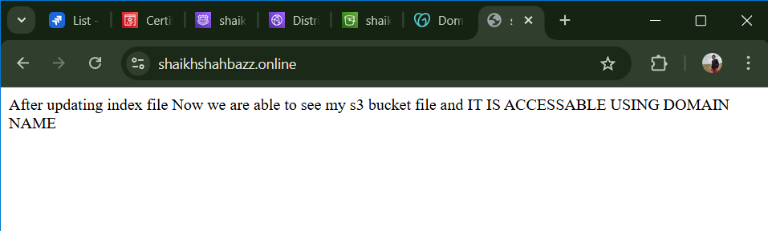

- Share the domain name in Slack to test the connectivity

<shaikhshahbazz.online>
